Technical Deep-Dive
Green Hydrogen for a Clean Steel Industry?

By Bernard Mairy

S.E.I.I. Executive Director
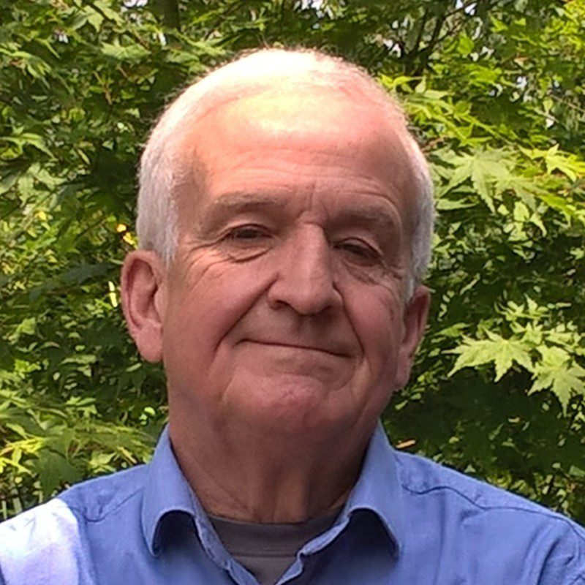

Green Hydrogen, a new star for the Steel Industry?
1.1. Since end 2019/early 2020, the so-called green hydrogen has become a new star in the ongoing debate for the decarbonation objectives. This debate is mainly concerning the electricity production, the transportation and more recently the energy-intensive industries. Green hydrogen is generated from renewable-based electricity and water electrolysers whereas grey hydrogen refers to conventional steam methane reforming without CO2 capture and blue with partial or total capture of the CO2 produced ; the latters are not considered in this paper.
For electricity production, a surprising enthusiasm for green hydrogen has been growing rapidly to further develop the renewable energy sources (wind, solar) but also to compensate for their inevitable intermittency. However, controversy from several energy experts has appeared to oppose the very poor technical efficiency (28% resulting from : 0.80 (electrolyser) x 0.70 (compression+transportation+storage) x 0.50 (fuel cell) = 0.28 for renewable-based H2) and the challenge of high-power water electrolysers as well as the anticipated high costs of such a new type of electricity production.
1.2. The present paper is dealing with the possible use of green hydrogen in the steel industry, one of the most energy-intensive heavy industries, actually not as an energy vector but instead as an alternative reductant. This would contribute to substantially reducing the CO2 emissions, specifically in the upstream ironmaking and steelmaking processes (the downstream processes like rolling and finishing are not considered hereafter).

The Steel Industry, a big player
2. As a preliminary to appraise the importance of the steel industry, some typical specific figures have to be recapped:
- End of 2020, the total world crude steel (CS) production was just 1.9 billion metric tons/y.
- The world steel production is responsible for 7–8 % of the global CO2 emissions i.e. around 2.6 billion tons CO2/y.
- The upstream iron and steel productions are mainly based on three routes (the percentages are worldwide ; see also figure below) :
a. Integrated route : Blast-Furnace (BF) + Basic-Oxygen Furnace (BOF) = 70% b. Scrap-based Electric Arc-Furnace (EAF) = 25%
c. Direct reduction of Iron Ore (DRI) + Electric Arc-Furnace (EAF) = 5%

Green Hydrogen to replace Carbon as Reductant?
3.1. The use of green hydrogen as reductant would concern routes a and c (route b is disregarded as being a melting process and therefore will not be further discussed). For routes a and c, the following simplified chemical reactions are prevailing :
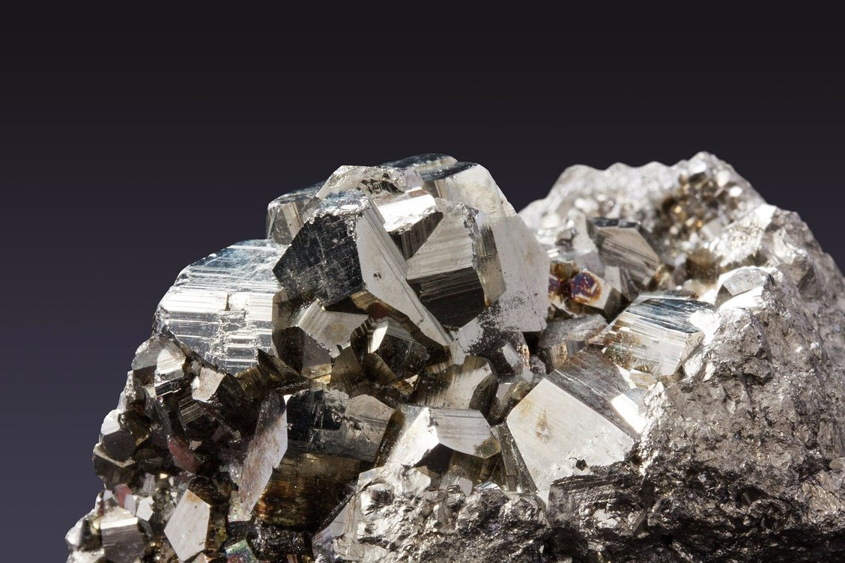
- Route a (BF+BOF) based on coke (distilled coal) and mostly injected coal as reductant:
In short, then in more details:
Fe2O3 +3CO = 2Fe + 3CO2
Fe2O3 + 3C = 2Fe + 3CO
Indirect reduction in BF:
3 Fe2O3 + CO = 2 Fe3O4 + CO2
2 Fe3O4 + 2 CO = 6 FeO + 2 CO2
6 FeO + 6 CO = 6 Fe + 6 CO2
Direct reduction in BF:
FeO + CO = Fe + CO2
CO2 + C = 2 CO
FeO + C = Fe + CO
Note: actually from top to bottom of the BF, successive reductions from Fe2O3 to Fe3O4andFeO then to Fe are taking place thanks to CO generated by coke and coal combustion.
- Route c (DRI) currently based on methane (CH4) as reductant:
Fe2O3 + ¾ CH4 = 2Fe + ¾ CO2+ 3/2 H2O
3.2. For route a (BF), the use of hydrogen to replace carbon as reductant would be rather limited to a few % H2 in the natural gas (up to estimated 30-35 kg H2/t hot metal) injected in the tuyeres (mostly to control raceway adiabatic flame temperature (RAFT) and to control H2 content in top gas; the coke rate of a BF is much lower in the operating mode with coal injection than that with natural gas, coke oven gas or oil injection). Basically, coke has to support the massive burden of loaded materials like iron ore lumps, sinter lumps, pellets and coke (bell coke and nut coke) all over the whole height of the furnace body as well as to allow, of course, the above-mentioned solid-gas chemical reactions.
Whereas for route c (DRI), hydrogen could technically replace up to 100% (for metallurgical reasons, however, a bit less than100% should be appropriate to avoid impacting the slag behaviour in EAF) on the basis of the following chemical reaction:
Fe2O3 + 3H2 = 2 Fe + 3H2O
Such a reaction would take place at very high temperature (above 1,000 °C) in a vertical shaft furnace charged with iron ore green pellets or lump ores.
3.3 By comparing the two above routes, it appears that the DRI route would offer more potential for the use of hydrogen as reductant than the BF route. Besides, the DRI route with hydrogen would match the so-called CDA technological EU objective (CDA stands for Carbon Direct Avoidance), which will introduce the next considerations.

The EU Decarbonation Challenge imposed to the Steel Industry
4. As the EU Commission has decided to take the lead in the decarbonation challenge (although EU only represents around 9–10% of the global world CO2 emissions), very ambitious targets have been defined for the EU steel industry which can be summarised as follows: the total CO2emissions of the steel industry should be reduced from 298 Million tons CO2in 1990 down to respectively 60 Million tons CO2 by 2050 for an 80% mitigation level and 15 Million tons CO2 by 2050 for a 95% mitigation level. For this estimate, it is assumed that the total EU steel production will stay at the 2015 level, i.e. 166 Million tons/y. This scenario will be a huge step to get over.
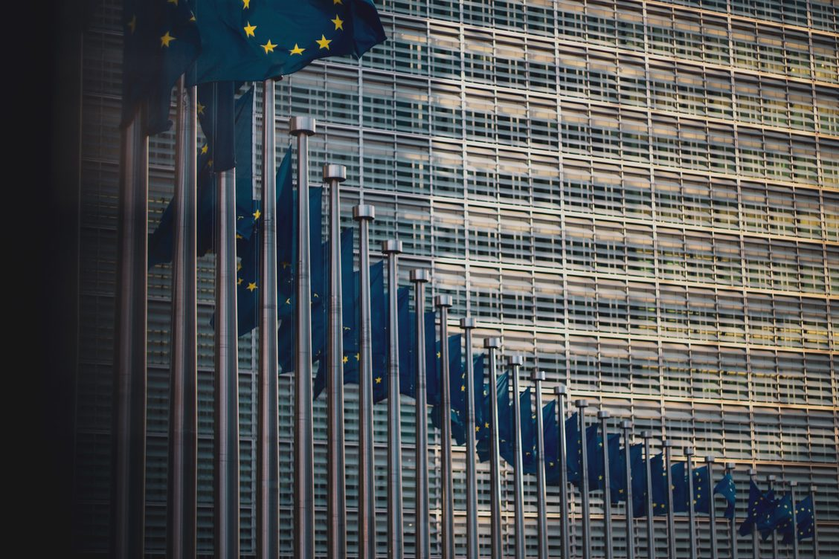

Industrial Demonstration Projects funded by EU
5.1. Consequently, it is not surprising that several demonstration projects have been recently started in the steel industry with EU financial funding in the frame of the so-called Smart Carbon Usage (SCU) and Carbon Direct Avoidance (CDA) technologies.
These technologies are key options to achieve the CO2 mitigation of the EU steel industry. More precisely, SCU includes the so-called CCS (Carbon Capture & Storage) and the CCU (Carbon Capture & Usage) technologies. CDA actually concerns the route b (scrap-based EAF) and the route c (DRI+EAF) as previously mentioned.
The demonstration industrial projects concern the following steel companies:
- BF route: ThyssenKrupp (D)
- DRI route : AG der Dillinger Hüttenwerke (D), ArcelorMittal Hamburg (D), ThyssenKrupp (D), Salzgitter (D) and SSAB/LKB (SE)
Note: for Smart Carbon Usage, other Demo projects are ongoing respectively at ThyssenKrupp with carbon2chem and ArcelorMittal with Igar/Steelanol : carbon2chem needs huge amounts of H2 (110 kg/ton CS) besides the 10 kg coming from the process gases, while Igar/Steelanol requests ca 60 kg H2 /ton hot metal to produce the amount of ethanol.
5.2. As it appears, most of them are located in Germany which for years has been seeking a very exclusive and expensive development of renewable energy sources (wind+solar) with lignite/coal/gas power plants(as back-up) for electricity generation.

Substantial Consequences in case of Scale-up of existing or new Steel Plants
7.1. For conclusion purposes, the following question could be addressed, i.e.: would such a huge breakthrough technological scenario make sense to achieve a clean steel industry?
More specifically:
- Would it be technically appropriate and financially/economically affordable for the steel industry without massive EU funding? Indeed, besides the high operating costs (OPEX), the investment costs (CAPEX) for such a breakthrough technological change would be tremendous and much time would be required for such a transition to take place in the steel industry.
Note : if EU funding could be justified for R&D purposes for elaborating and testing such demo plants, any EU funding, however, contributing to the capital costs for building a brand new DRI/EAF plant as well as to the operating costs related to green hydrogen as feedstock would not be acceptable according to the EU regulations and the free trade obligations (EU TFEU articles 107(1) & 107(3)).
- Are renewables the best suited energy source to produce huge amounts of green hydrogen for switching towards the DRI/EAF route with green hydrogen?
Note: while EAF’s are rather flexible processes allowing load shedding services to the grid, the DRI process is a baseload process that must run 24/7 and hence, be fuelled with a continuous flow of hydrogen.
Therefore, two solutions are: (1) to overdesign the electricity production with massive hydrogen storage capacity (with the associated consequence on hydrogen cost) or (2) to build gas power plants to compensate for solar & wind intermittency (with the associated increase in CO2 emissions).
7.2. As an alternative scenario to the requested huge green hydrogen production, would it not be more relevant to envisage producing large amounts of green hydrogen – without the intermittency issue – through a nuclear-based approach. Indeed, water steam pyrolysis could be provided by advanced high temperature gas cooled nuclear reactors (HTGR) with Helium as reactor coolant and heat vector, or by molten salt reactors (MSR) providing heat sources in a temperature range between 600 and 1,000 °C? The pyrolysis of water at high temperature would be obtained through specific thermochemical reactions involving chemical products to be recycled. Such Gen-IV-type reactors for electricity & heat production are presently under development in most G20 countries. On top of the operational compatibility (dispatchable energy production), advanced reactors could be installed right next to consumption points, greatly cutting down on transport and distribution costs. However, such a nuclear approach would obviously depend on the energy policy of the country concerned.
Ir Bernard MAIRY
- SEII Executive Director
- AIST & AIST-DRI Committee (USA) Member
- VDEh Stahl Institut (D) Member
- BNS Member
Note : the DRI technology has been growing despite the CO2 issue related to methane as reductant but would be boosted by the use of green hydrogen as reductant provided the answers to the above questions could receive a positive reply. This technology is currently provided by two main builders, respectively MIDREX (USA) and TENOVA(AR) & DANIELI (Italy).

References:
- Dr-Ing Hans-Bodo LUNGEN, Stahlinstitut VDEh,Schlüsselwege zur CO2-Minderung der Stahlindustrie, Stahl+Eisen, March 2021.
- Alisha GIGLIO, HATCH, AIST March 2021 Recent Sustainability Development in the Iron and Steel Industry
- Tksteel,Stahl & Eisen Jan+Feb/2021 Erste Direktreduktionanlage mit Einschmelzer
- Dr-IrSamuel FURFARI : The Hydrogen Utopia
- IEA International Energy Agency, 2019 Hydrogen Report
- MIDREX : private communication
- World Crude Steel production – Industry Statistics. AIST March 2021
- EUROFER EU-28 Steel Statistics: website
- Proceedings IEEE Oct.2006, p1835, Ulf BOSSEL
- UK Energy System Modelling : Net Zero 2050. National Nuclear Laboratory 2021
- Peter MARCUS & John VILLA, Strategic Insights from WSD, AIST Issue of July 2021
- ArcelorMittal press release July 29, 2021
- Ch.HEINE , Revue ELECTRICITE, n°164, June 1977
Page 9 sur 9

